OUTPUT FILE
--- 1. LASSO Regression ---
Model: LASSO Regression
Alpha Hyperparameter: 0.1
Parameter Values (Coefficients):
[ 2.48496761 -1.49206889 -0. 0.77077978 0.01063494 0.
-0. 0.24363542 -0. 0. ]
Mean Squared Error (MSE) on Test Set: 0.2446
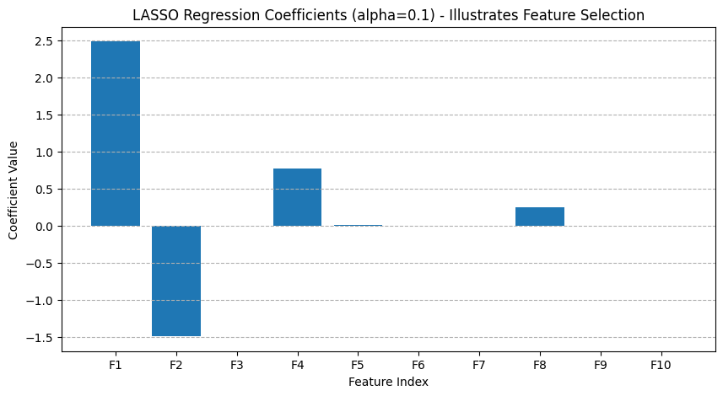

--- 2. K-means Clustering ---
Model: K-means Clustering
K Hyperparameter: 2
Parameter Values (Cluster Centers - Scaled):
[[ 0.89758627 0.91008317]
[-0.89758627 -0.91008317]]
Inertia (Within-Cluster Sum of Squares): 36.61
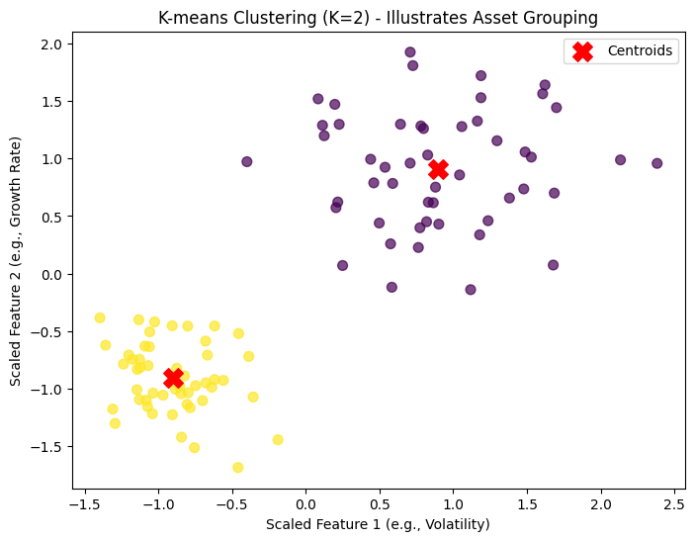

--- 3. Principal Components Analysis (PCA) ---
Model: PCA
n_components Hyperparameter: 3
Explained Variance Ratio by Component: [0.8921706 0.07240716 0.03542224]
Cumulative Explained Variance: [0.8921706 0.96457776 1. ]
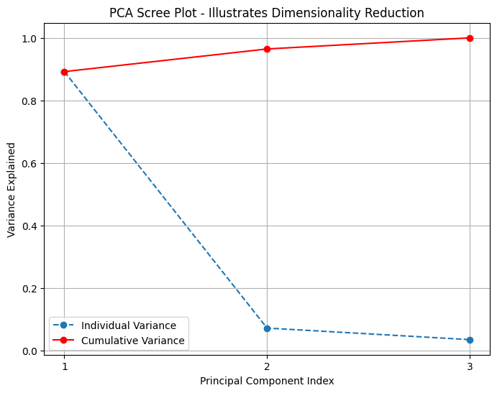

--- 4. Regression Trees ---
Model: Decision Tree Regressor
Max_Depth Hyperparameter: 3
Mean Squared Error (MSE) on Test Set: 0.2234
Feature Importances: [0.96004147 0.03995853 0. ]
